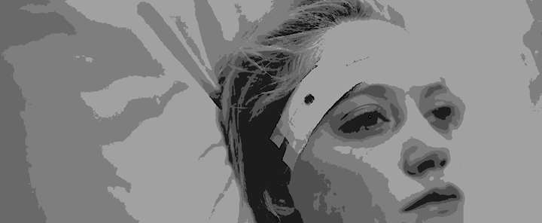
Scratch Image Only
Plot ->
A house wife (Amutha) awakens as a patient in a hospital, with no memory of the previous night. As she tries to regain her memory, the actual incident is reported to police by the only witness, her husband’s sister.
Note 1 (Tempo)
Tension building through suspense to the point where the audience is treated with successive scary moments on screen towards the finale
Note 2
The script has scary moments but nothing paranormal. Even the scariest scene will be within the frame of scientific explanations / very human.
Note 3 (Music)
There are two songs in total, out of that one will be the theme music of which the lyrics will be recited as a poem (male) in the first half and the same will repeat as a song (female) in the second.
TREATMENT ->
The whole script is focused on revealing the character ‘Amutha’, ie the ‘Amutha’ through the eyes of Anjana (Amutha’s sister in law), Dr. Gopala Ratnam (doctor who treated Amutha during her school days), and Amutha herself.
Anjana’s version of ‘Amutha’ starts in the second half and ends with climax, ie just before the last scene.
Second half shows Amutha’s gradual transformation from an innocent and silent house wife to a person experiencing Psychosis.
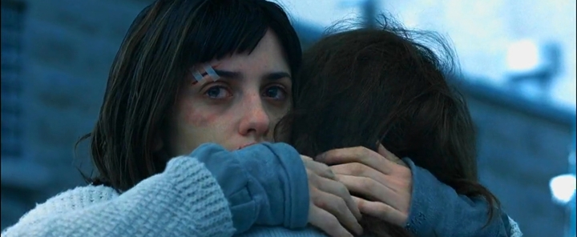
Scratch Image Only
A SCENE FROM THE SCRIPT
INT. HALL, BUNGALOW - DAY
ANJANA hears the soft sound of WHISPERING from nearby. The sound of WHISPERING continues. As she slowly walks to the door, we can make out some words:
AMUTHA (O.S.) ‘I no longer have any more tears’
ANJANA listens for a moment, then opens the door.
INT. BEDROOM 1, BUNGALOW - DAY
AMUTHA, sitting up in bed, turns towards ANJANA.
ANJANA ‘Amutha, who were you talking to?’
AMUTHA looks up at ANJANA with pleading eyes.
AMUTHA ‘I want to tear my aching heart piece by piece so I no longer feel lonely…’ reciting a sentence from THE BOOK she is holding.
ANJANA sits down next to her.
ANJANA ‘You were reading poem? Please read it for me’
AMUTHA’s eyes move to the wall behind ANJANA -- ANJANA follows her gaze, looking back – slowly – nothing, nobody – ANJANA turns back to AMUTHA –
AMUTHA (Smiling) ‘I am reading, listen’
ANJANA (Smiling) ‘Sweet Amutha… Read’ (pinching AMUTHA’s cheeks)
AMUTHA start reciting the poem ‘I want to cry, but I no longer have any more tears…’
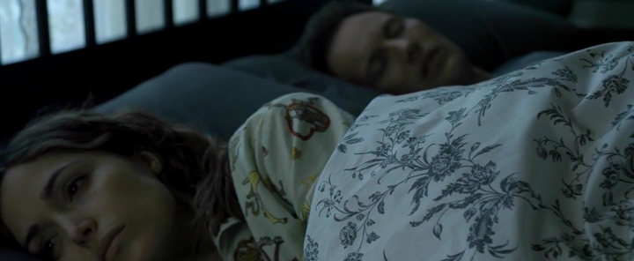
Scratch Image Only
The Character Amutha ->
Amutha apparently had a difficult childhood after losing her mother even before opening her eyes. At the age of four, she saw a man killing her father, during this shocking event, she saw another little girl (herself) watching this from outside the house. Since then she started seeing weird dreams, complex visual hallucinations, until the age of 14 when the treatment was successfully completed (These incidents are told through a doctor who treated Amutha). She lost her brother in a bike accident at the age of 25. Soon after the incident her relatives forced her to marry Gautham, who was a successful businessman. Within few weeks after the marriage she started feeling isolated again when Gautham started going for business meetings and not returning for few days. Slowly, Amutha started showing unusual shifts in mood, energy, and activity levels.
Towards the end (ie Anjana’s story), Amutha is shown as a person who doesn’t get proper sleep, Amutha is shown crying quite often with a negative outlook on life, poor eye contact with others, speaking in a rapid manner. In one scene, she is shown as if she has lost the contact with reality.
The story is based on a real life incident ->
In 1979, a lady named Juanita Maxwell (23) was working as a hotel maid in Fort Myers, Florida. A 72-year-old hotel guest Inez Kelley was brutally murdered; she was beaten, bitten, and choked to death. Maxwell was arrested because she had blood on her shoes and a scratch on her face. She claimed she had no idea what happened.
Additional Note
The script written is suitable/easily adaptable for any language audience as it doesn’t go through/surrounds any specific tradition or culture.
The director has experience and is comfortable with Tamil, Hindi and Malayalam.
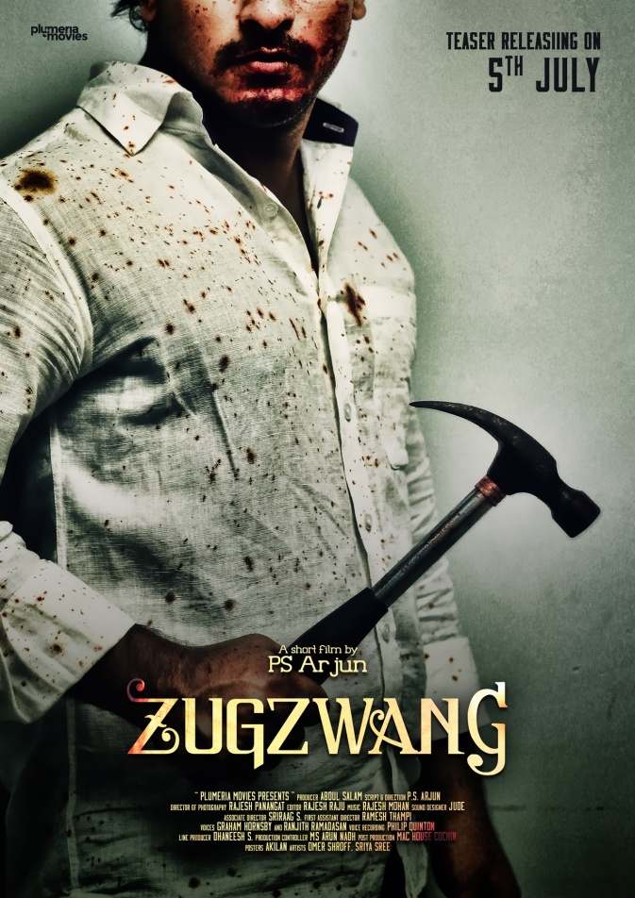
Main Crew – Preferences
- Script & Direction: P.S. Arjun, Film-Critic & Column Writer, award winning Indie and ad Filmmaker, did Digital Filmmaking and Script-Writing courses. His recent major work: Zugzwang (2016, English) Short Film.
- Music: Revathy, Tamil Industry, did 40+ jingles for commercials, did highly popular music albums, currently doing her first feature film.
- Director of Photography: Rajesh Panangat, Documentary and Ad film DoP.
- Editor: Jithin John, Editor at Sun Networks, and worked with P.S. Arjun for the acclaimed short film ‘Zugzwang’, edited over 30 music albums and commercials, worked as spot editor in Idhu Namma Aalu (Tamil), Welcome to Central Jail (Malayalam) and more.
Project Duration & Location
Pre-Production: 45 Days I Shooting: 40 Days I Post-Production: 60 Days l A Hill Station

BUDGET
Estimate Max budget including Wide Scale Online & Print-Media publicity – 2 Cr (without artists) and 2.5 (with two popular female artists)

